CONTRACTOR SAFETY HANDBOOK

SUMCO PHOENIX CORPORATION

Phoenix, Arizona

Albuquerque, New Mexico

1. Purpose

The purpose of this handbook is to define responsibilities and provide guidelines for planning and implementing contract work at the SUMCO Facilities locations in Phoenix, Arizona (SPP) and Albuquerque, New Mexico (SPQ).

1. Scope/Application
   1. It is essential to the safety and health of all personnel that job hazards be identified and safety procedures explained through the course of any work involving SUMCO contractors.
   2. This program addresses many of the hazards and practices commonly associated with maintenance or construction related projects.
   3. This program also addresses requirements for those contractors performing work on facilities or equipment related to the Occupational Safety and Health Administration’s Process Safety Management (PSM) Standard and the Environmental Protection Agency’s Risk Management Program (RMP). **Applicable to SPQ Only.**
   4. When necessary, additional guidelines tailored or amended to the specific job or site may be required.
   5. SUMCO is subject to ISO 14001 requirements. Deviation from this procedure may lead to an unintended environmental impacts.
2. Policy
   1. It is the policy of SUMCO to implement procedures to manage risk associated with independent contractors working at SUMCO facilities.
3. Applicable or Reference Documents/Procedure, Forms, Software
   1. CORP_EHS_SOP-0068, *SPXS Access Control Program*
   2. CORP_EHS_SOP-0066, *SPX Hot Work Program*
   3. CORP_EHS_SOP-0060, *Electrical Safety*
   4. CORP_EHS_SOP-0053, *SPX Hazard Communication Plan*
   5. CORP_EHS_SOP-0055, *Weld, Cut and Braze Safety*
   6. CORP_EHS_SOP-0061, *Lockout/Tagout and Control of Hazardous Energy*
   7. CORP_EHS_FORM-0034, *Pre-Startup Safety Review*
   8. CORP_EHS_WI-0006, *Portable Ladder Safety*
   9. CORP_EHS_WI-0007, *Cranes and Hoist Procedures for Users*
   10. CORP_EHS_POL-0003, *Banned/Restricted Chemicals and Chemicals requiring Disclosure*
   11. PHX_MFG_SUP_WI-0317, *Clean Room Protocol*
   12. ABQ_GEN_WI-0219, *General Clean Room*
   13. ABQ_GEN_WI-0220, *Gowning: General*
   14. PHX_MFG_SUP_SOP-0132, *Confined Space Entry*
   15. ABQ_EHS_WI-0283,, *Confined Space Entry*
4. Terms and Definitions
   1. **Confined Spaces** - Any space with restricted access or egress where (because of the construction, locations, contents or nature of the work done inside) hazardous, gaseous vapors, dusts, or fumes may accumulate, or where oxygen may be deficient.
   2. **Contractors** - A person, business, or corporation that provides goods or services to SUMCO under terms specified in a contract.
   3. **Environmental Protection Agency** - an agency of the U.S. federal government charged with protecting human health and the environment. **Hot Work** - Any process that can be a source of ignition when flammable material is present or can be a fire hazard regardless of the presence of flammable material in the workplace. Common hot work processes are welding, soldering, cutting, grinding and brazing.
   4. **Job Task Review Meeting** – Daily meeting conducted between the contractor and the SUMCO Sponsor/Project Manager prior to the start of daily work activities. Information reviewed in the meeting includes, but are not limited to, job/task details, schedules, associated procedure(s), job and area hazards and PPE requirements.
   5. **Lockout-Tagout (LOTO)** - A safety procedure which is used to ensure that dangerous machines are properly shut off and not started up again prior to the completion of maintenance or servicing work.
   6. **Occupational Safety and Health Administration** (OSHA) - an agency of the United States Government charged with assuring safe and healthful working conditions for employees and contractors.
   7. **Personal Protective Equipment (PPE)** - The equipment and clothing required to mitigate the risk of injury from or exposure to hazardous conditions while on the job.
   8. **Process Safety Management (PSM Standard)** - A safety regulation designed to reduce the frequency and severity of chemical process related incidents. **The PSM Standard applies to SPQ Only.**
   9. **Rally or Muster Point** – Previously determined gathering locations at SUMCO for employees in the event of a facility or work area evacuation. Rally Points (SPP) are designated by a large white triangle painted on the asphalt with the identifying mark ‘RP’ painted inside the triangle. Rally Points are also depicted on Evacuation Maps located in work areas. Muster Points (SPQ) are pre-designated areas outside the facility where evacuated employees will assemble.
   10. **Risk Management Program (RMP)** - An EPA regulation designed to prevent harmful chemical releases to the surrounding environment. **This regulation applies to SPQ only.**
   11. **Safety Data Sheets** - Informational fact sheets that identify hazardous chemicals and health and physical hazards, including exposure limits and precautions for workers who may come into contact with these chemicals.
   12. **SUMCO** – SUMCO Phoenix facilities, either SPP (Phoenix, AZ) or SPQ (Albuquerque, NM).
   13. **SUMCO Sponsor/Project Manager** – SUMCO employee responsible to oversee the job or project for which the governing contract was issued.
5. Responsibility / Authority
   1. Contractors
      1. Contractors are to provide their employees with all Federal, State and / or Local government required training, testing and/or certification, applicable to the work being performed at SUMCO.
      2. Contractors will conduct work activities in accordance with all Federal, State and / or Local government regulations and industry standards.
      3. While planning and performing work at SUMCO, contractor employees are required to observe and obey this Contractor’s Handbook at all times.
      4. It is the contractor’s responsibility to disseminate the information in the Contractor’s Handbook to their employees and subcontractors, prior to performing any work at SUMCO.
      5. Prior to the start of any on-site work or project, the contractor(s) will review SUMCO SOP’s, WI, forms, policies and guidance documents [see Section 3.0] related to the project.
      6. Personal Protective Equipment (PPE) - Contractors are to provide and enforce the wearing of all safety apparel or equipment necessary to protect their workers from either hazards present in the work environment or those created by the work being performed, (excepting cleanroom and acid garments) in compliance with OSHA regulations and industry standards.
      7. SUMCO requires that current ANSI standard safety glasses be worn in all operational areas of the facility. Contractors are required to wear safety glasses in similar situations, whether posted or not, and where their own activities may expose them to eye hazards.
      8. Contractors will observe and follow all posted warnings and notices. (e.g.; wear eye protection, no smoking, clean room garments, etc.)
      9. Second tier subcontractors are the responsibility of the main or primary contractor, but subject to the same rules governing the main or primary contractor while performing work.
      10. **The employees of independent contractors are NOT under the supervision of SUMCO. With the exception of the PSM/RMP Programs the contractor has full responsibility for maintaining injury and illness records for their employees**.
      11. Failure to comply with this Contractor Handbook and or any applicable codes or regulations is reason for immediate termination of contract and or services.
      12. ALL contractor employees must complete and sign the Contractor’s Handbook quiz to demonstrate they have read and understand the contents of Contractor’s Handbook PRIOR to beginning work at the site.
   2. SUMCO Sponsor/Project Manager
      1. SUMCO maintains many Standard Operating Procedures (SOP), Work Instructions (WI), forms, policies and guidance documents in its document control system. When performing initial project scoping, the SUMCO project manager will make the documents that are relevant to the contracted work available to the contractor for review.
      2. Prior to the start of each day’s work, the SUMCO sponsor/project manager and contractor(s) must conduct a job task review meeting.
      3. Hot Work: The SUMCO sponsor/project manager will issue a Hot Work Permit with signature approval of the EHS Staff or their designee in accordance with the Hot Work Policy for any hot work being conducted on site.
      4. Control of Hazardous Energies or Lock-Out/Tag-Out: The SUMCO sponsor/project manager will always be the primary Lockout/Tag out authorized person who will shut down and lockout the equipment.
6. General Procedures
   1. Restricted Activities
      1. All SUMCO facilities are tobacco-free. The use of any tobacco-containing products (with the exception of tobacco-cessation products) is STRICTLY PROHIBITED anywhere on SUMCO Property.
      2. No alcohol or drug use is allowed on or within the plant site.
      3. Firearms and weapons of any type are strictly prohibited.
      4. No cameras or video recorders are allowed on or within the plant site unless approved by the SUMCO Sponsor/Project Manager.
      5. Eating and/or drinking are not allowed in work areas but only in designated break rooms.
      6. Contractor vehicles may not block access and/or egress to any SUMCO building or facility
      7. SUMCO company phones are for SUMCO business. Contractors are expected to use their cell phones to make calls.
      8. Horseplay and similar unsafe behaviors are strictly prohibited.
   2. Site and/or Facilities Access
      1. All contract personnel will sign-in and sign-out at the Security Office (SPP) or Front Lobby Desk (SPQ) when entering or leaving the building.
      2. When contract personnel sign-in at the Security Office (SPP) or Front Lobby Desk (SPQ) they will be given a badge appropriate for the scope-of-work to be performed. These badges must be worn by the contractor and their employees while on-site at SUMCO and returned to the Security office or SUMCO representative at the end of the work shift. See **Exhibit 1** and **Exhibit 2** below for the types of SUMCO badges and corresponding descriptions.
      3. Contractors with longer-term scopes-of-work may be issued an access badge for the term of their Contract Purchase Agreement or scope-of-work but must still sign in and out daily. These badges must be worn by the contractor personnel while on-site at SUMCO and collected prior to exiting the facility. **Figure 1** presents the process for determining the type of badge required.

**Exhibit 1**

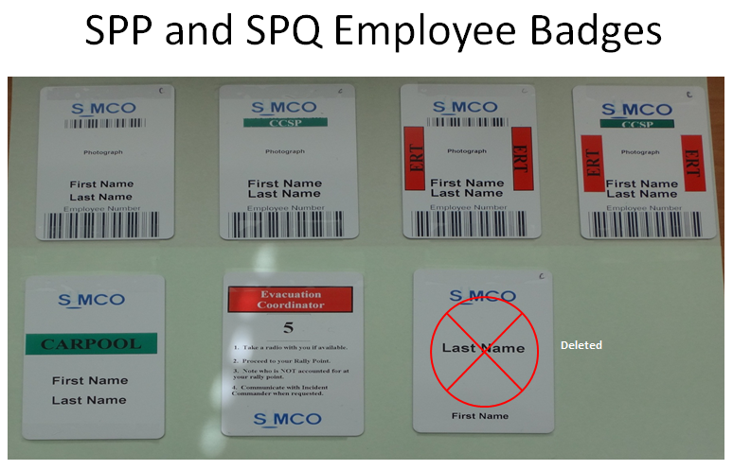

**Exhibit 2**

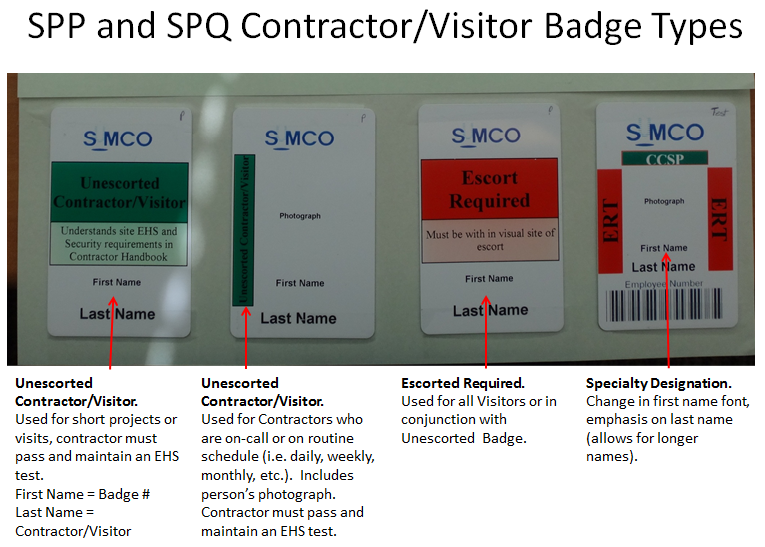

**Figure 1**

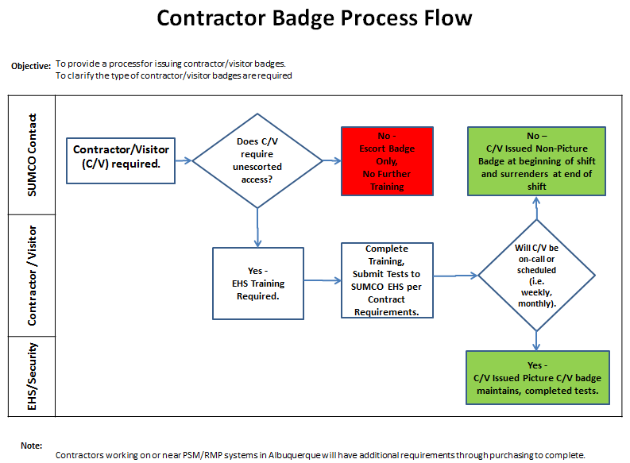

* + 1. Access to SUMCO work areas is restricted. Blocking open doors or modifying latching mechanisms to maintain a door in an open or unlocked position is strictly prohibited.
  1. Staff Support
     1. The Environmental, Health and Safety (EHS) department routinely interfaces with contractors to evaluate the contractors work relative to established EHS protocols and provide guidance and/or consultation as appropriate.
     2. If you, the contractor/vendor, have any questions regarding this handbook you may contact the EHS Department by contacting **Security at 5555** (SPP) or your SUMCO Representative and they will direct you to the appropriate staff personnel.
  2. Work Subject to OSHA’s PSM / EPA’s RMP Programs – **SPQ Only**

7.4.1 Prior to beginning work on any facilities or equipment subject to PSM/RMP requirements, contractors are required to provide SUMCO with relevant information documenting contractors’ safety performance and programs. At a minimum this includes:

* A Written Safety Program;
* Evidence of Safety Performance Metrics or Indicators Documenting Illness or Injuries; and
* Copies of Employee Safety Training Records.

7.4.2 SUMCO will provide contractor with the known potential fire, explosion, or toxic release hazards related to the contractor’s work on facilities or equipment subject to the PSM/RMP standards.

7.4.3 SUMCO will explain to contractor’s employees the applicable provisions of SUMCO’s Emergency Action Plan.

7.4.4 SUMCO will assist contractors to control the safe entrance, presence, and exit of contract employees in areas covered by PSM/RMP-related process areas.

7.4.5 SUMCO will periodically evaluate the performance of contractor’s performing PSM/RMP-related work.

7.4.6 SUMCO will maintain an injury and illness log related to contractor’s work in process areas.

7.4.7 Each contractor shall assure that their employees are trained in the work practices necessary to safely perform his/her work.

7.4.8 Contractor will assure that their employees are instructed in the known potential fire, explosion, or toxic release hazards related to his/her job and the process and applications of SUMCO’s Emergency Action Plan.

7.4.9 Contractor shall document that each employee under their direct control has received and understood training related to the above requirements. Accordingly, contractor shall prepare a record which contains the identity on the contract employee, the date of training, and the means used to verify that the employee understood the training.

7.4.10 Contractor shall ensure that each of their employees follows SUMCO’s safety rules and safe work practices related to work performed on facilities and equipment subject to the PSM/RMP standards.

7.4.11 Contractor will advise SUMCO of any unique hazards encountered by contractor in the performance of contractor’s work.

1. Environmental, Health and Safety [EHS] Guidelines and Practices
   1. Accidents/Incidents and Emergency Procedures
      1. If a contractor experiences any accident while on site involving personnel, spilled chemicals or property damage or any other emergency, they must notify their SUMCO contact immediately or call:

* In Phoenix, **480-473-6900 ext. 5555** (Security)
* In Albuquerque, **505-346-6388** (EHS)
  + 1. Information provided to Security will include at a minimum:
       - Location of incident
       - Nature of the incident (spill, fire, injury, etc.)
       - Identification of any personnel involved in the incident
       - Materials/chemicals involved in the incident
       - Quantity of material involved
    2. In the event of an emergency (e.g., fire, hazardous material release, earthquake, etc.) contractors must follow all instructions received over the public address system and all directions from the SUMCO Emergency Response Team (ERT).
  1. Evacuations/Fire Alarms
     1. Contractors present during any plant evacuation, must follow the SUMCO Evacuation policies.
     2. Every contractor shall know the closest Rally Point to their work location.
     3. In the event of an evacuation or fire alarm, a loud alarm will sound in the affected area.
     4. Contractors must evacuate to the nearest exterior Rally Points. Either by following SUMCO personnel or exiting the building through any identified exit door.
     5. All contractors evacuating must assembled at the Rally Point and identify themselves to the Evacuation Coordinator.
     6. No contractor may leave the Rally Point or re-enter the building until told to do so by the Evacuation Coordinator.
  2. Hazardous Materials
     1. Copies of Safety Data Sheets (SDSs) for chemical materials used by the contractor must be provided to the EHS Department prior to commencement of the project.
     2. Copies of SDSs for SUMCO’s chemical materials are available from the EHS Department.
     3. The facility uses the Global Harmonized System (GHS) and HMIS systems to label chemical containers that do not have the original manufacturer’s product label.

**Example GHS Label**

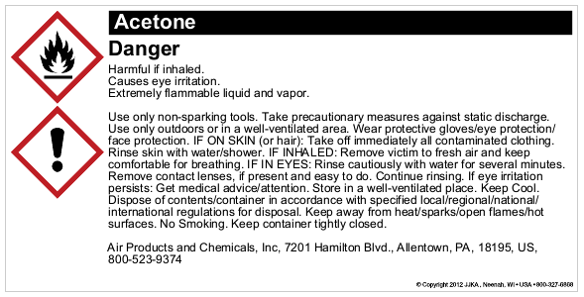

**Example HMIS Label**



* + 1. Flammable liquids may not be used to wash down any parts of the building structure, (floors, walls, etc.)
    2. No SUMCO chemicals may be removed from any work or storage areas for use on a contract job without the approval of the Maintenance Department AND the EHS Department.
    3. All compressed gas cylinders must be properly secured at all times.
    4. Acetylene cylinders must always be stored and used in an upright position.
    5. All cylinders must be capped when not connected for use.
  1. Waste Disposal
     1. Contractor projects will often generate waste materials including chemical waste as well as other liquid and solid wastes.
     2. SUMCO requires that all wastes be managed through SUMCO’s on-site programs.
     3. The contractor and the project manager must make every attempt to identify all potential wastes generated PRIOR to the start of the job and notify and get approval from the EHS department. (This is usually done through the AFE or the Non-Routine job analysis process.)
     4. The contractor may never pour liquid waste in to sinks, drains, storm drains or sanitary sewers.

1. Contractor Work Requirements
   1. Clean Room Access And Work
      1. Contractors required to enter the Clean Room(s) will be required to follow the special rules for gowning and cleanroom activity. Refer to SUMCO Clean Room and Wipe Down Procedures
      2. Contractor training may be required prior to gaining access to the Clean Room(s).
   2. Confined Spaces
      1. Before a contractor may perform work in a confined space, (e.g., manholes, pits, tanks, vaults, etc.) the Maintenance Manager must be notified and must participate in the characterization of the confined space.
      2. All procedures in the Confined Space Program must be followed by all contractors.
      3. Contractors must have their own written confined space program including permitting, PPE and testing equipment.
   3. Control of Hazardous Energies (Lock-Out/Tag-Out)
      1. When shut-down of a system is required, SUMCO lockout/tag out procedures will apply.
      2. In all cases, a SUMCO representative will always be the primary Lockout/Tag out authorized person who will shut down and lockout the equipment.
      3. Contractors will apply as many secondary locks as appropriate for the work they are performing.
      4. At the conclusion of the work, all secondary locks must be removed by their respective owners after which the SUMCO representative will remove the primary lockout device and reactivate the equipment.
      5. Contractor personnel must not, under any circumstances, operate any switch or valve used to control building services, or equipment, or remove any lockout device or tag.
      6. Contractor personnel shall not tamper with or operate any fire system or sprinkler controls unless authorized by the SUMCO Site Services Manager.
   4. Electrical Equipment
      1. All electrical equipment used on the job shall be properly grounded.
      2. Ground-fault circuit interrupters (GFCI) are required for outlets which are not part of the permanent wiring of the building to which cord connected equipment is attached.
      3. Daisy chaining, or doubling up of extension cords is prohibited.
      4. Lights or portable tools used or carried into hazardous locations must be an explosion-proof type (approved for Class 1, Div II, Group D service by UL or FM).
   5. Floor Openings and Excavations
      1. When not being worked on, all floor openings and excavations must be covered with planking or other materials of adequate strength to support any potential load.
      2. Such floor coverings must be adequately marked and protected at all times.
      3. In lieu of the above coverings, standard guardrails and toe boards may be installed per OSHA regulations.
      4. Excavation and trenching over 5 feet in depth shall be adequately shored or sloped per OSHA regulation.
   6. Fumes, Smoke and Vapors
      1. The use of internal combustion equipment in occupied buildings must be pre-approved by the Maintenance Manager.
      2. Use of internal combustion equipment in occupied buildings should be kept to a minimum and portable blowers and ventilators may be provided. Air or electrically driven equipment should be used whenever possible.
      3. When paints, adhesives, or other vapor producing materials are applied to walls, floors, and other parts of the facility,
         * The material must be pre-approved for use by EHS
         * Adequate ventilation must be provided to prevent the accumulation of noxious fumes that could result in either health or fire hazards.
         * If this requirement cannot be met to the satisfaction of the personnel in the area and/or EHS, the Project Manager may order the job to be performed when the area is unoccupied.
   7. Hot Work Policy (Welding, Cutting, Brazing, High Voltage Electrical)
      1. Absolutely no hot work will be performed anywhere on the plant site without the prior completion of a Hot Work Permit (CORP_EHS_FORM-0032) with signature approval of the EHS Staff or their designee in accordance with the Hot Work Policy (CORP_EHS_SOP-0066)
      2. Adequate shielding must be provided around all locations where electrical arc welding is being performed.
      3. Appropriate signs must be posted to warn surrounding personnel of welding hazards.
      4. During welding or cutting operations, the following provisions are must be taken:
         * Proper fire extinguisher at work location
         * Use fire retardant tarps or covers when applicable
         * Remove as many combustible materials as possible from the exposed area
         * Post a fire watch to remain at the job site at least 30 minutes after completion of the work
   8. Housekeeping, Aisles and Walking Surfaces
      1. All areas of the plant will be maintained in a neat and orderly fashion at all times. . (e.g.; some projects create a temporary mess)
      2. All emergency exits, aisle ways and other walking surfaces must be kept free and clear of clutter, equipment, tools and / or materials at all times.
      3. Air hoses, power and extension cords must be arranged to minimize tripping hazards.
      4. Liquid spills must be contained immediately and cleaned up without delay. Major releases (those over 5 gallons) must be reported immediately to Security at extension 5555.

The job site should be taped off with CAUTION tape to exclude unauthorized persons.

* 1. Noise Control
     1. Contractor’s operations involving the use of equipment and tools which produce excessively high noise levels (85 dBA or over) are prohibited in occupied areas. .
  2. Overhead Work
     1. When contractor employees must perform work exposing them to a fall in excess of 4 feet, the contractors must provide fall protection necessary to prevent injury and hard hats and high visibility vests as appropriate.
     2. All fall protection must be in compliance with OSHA regulations and Industry Standards.
  3. Power Actuated Tools
     1. The use of power actuated tools must be scheduled with and approved by the Maintenance Department.
     2. Only trained and will be allowed to operate power-actuated tools.
     3. All power-actuated tools will be tested daily when in use and all defects will be corrected before use.
     4. Tools will not be loaded until needed for immediately use.
     5. Loaded tools will not be left unattended.
  4. Use of Equipment, Tools and Storage Areas
     1. Contractor personnel are to furnish any and all equipment and tools necessary for the performance of their work including but not limited to:
        + Personal protective equipment and fall protection equipment
        + Atmosphere testing equipment
        + Power lifts and material handling equipment
        + Hand tools, power tools and cleaning equipment
        + Scaffold, planking and guardrails, ladders and portable stairs
        + Vehicles of any type
        + Computers, fax machines, phones, copiers, printers, etc.
     2. Contractor equipment must be suitable for use, in good repair and labeled (or otherwise identified) with the contractor’s company name.
     3. The Contractor MUST remove all equipment and tools at the end of the contracted job.
     4. All job related chemicals must be properly stored at the end of the daily tasks or removed from the facility.

1. **Environmental Stewardship and ISO 14000**
   1. SUMCO facilities are certified through the International Organization for Standardization (ISO) for having an effective Environmental Management System (EMS). This certification is commonly known as ISO 14001.
   2. Part of the requirements of the EMS program is that SUMCO communicates the EMS requirements and environmental policy to contractors and vendors.
   3. All contractors and their employees at any SUMCO facility must understand :
      * The environmental impact, if any, of their work and how to minimize it.
      * How to report an emergency, attend to an injury and evacuate the facility
      * How to any waste generated as part of their work.
      * Environmental regulations associated with their work
      * The existence and location of SUMCO’s Environmental Policy
   4. Environmental Policy
      1. SUMCO has an Environmental Policy that it posted prominently at each facility. Contractors should be familiar with and able to locate this policy upon request. The Environmental Policy reads as follows:

**SUMCO PHOENIX ENVIRONMENTAL POLICY STATEMENT**

“SUMCO Phoenix is committed to Environmental Excellence and to having its activities performed in a manner consistent with the principles of responsible environmental stewardship. Toward that end, SUMCO Phoenix will develop and maintain an Environmental Management System that accomplishes:

* **Pollution Prevention**
* **Continual Improvement**
* **Compliance with Environmental Legislation, Regulations and Other Regulations**
* **Setting and Reviewing Environmental Targets and Objectives.**

Acknowledgement Form

Contractor Employee: After reading the Contractor’s Safety Handbook complete the form below, remove it and return it to your SUMCO representative.

This is to certify that I have read and understand SUMCO Phoenix Corporation’s Contractors Safety Handbook and agree to abide by its contents.

___________________________ ________________________

Print Name above Date

___________________________ ________________________

Signature Company Name